Mathematics: Specialist
Formula sheet Units 3C and 3D

Vectors

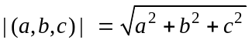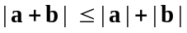
ab = |a| |b| cosѲ = a₁b₁+a₂b₂ ₊ a₃b₃
Vector equation of a line in space:
one point and the slope: 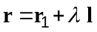
two points: 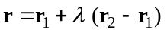
Cartesian equations of a line in space 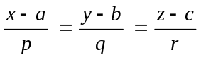
Parametric form of vector equation of a line in space 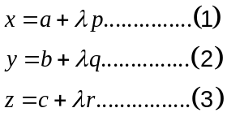

Equation of a plane rn = c
(r – a)n = 0

Trigonometry

In any triangle ABC
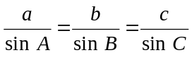 Area 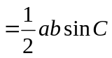
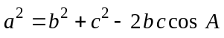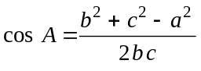
In a circle of radius r, for an arc subtending angle (radians) at the centre:
Length of arc = 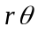 Area of sector = 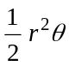 Area of segment = 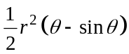

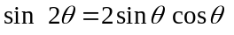
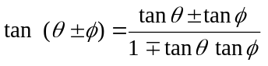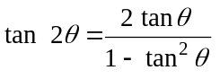
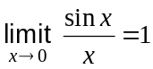 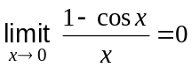,
Simple Harmonic Motion: If 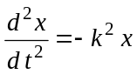 then 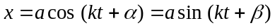

Exponentials and logarithms

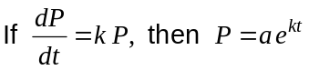

Functions

Differentiation
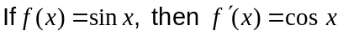
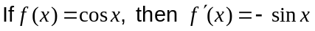
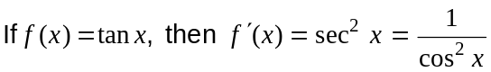

 | Function notation |  | Leibniz Notation
 |  | 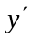
Product rule | 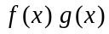 | 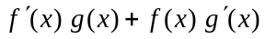 | 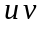 | 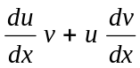
Quotient rule | 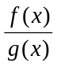 | 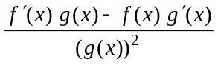 |  | 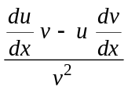
Chain rule | 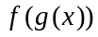 | 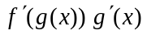 | 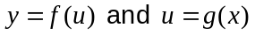 | 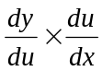

Integration
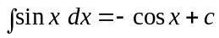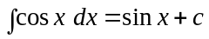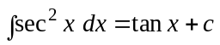
Fundamental Theorem of Calculus: 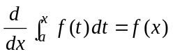and 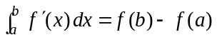
Complex numbers
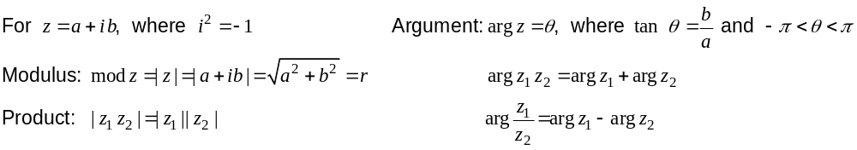
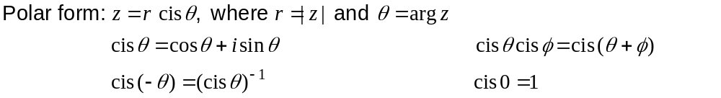
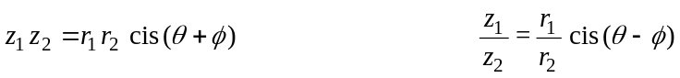
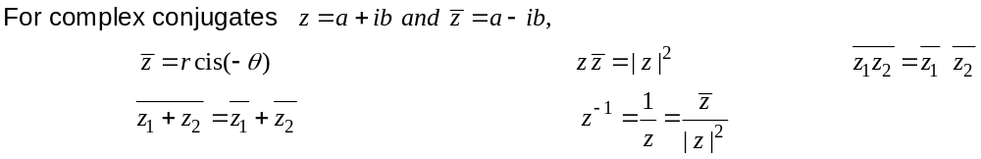

Matrices

If A = 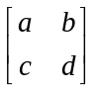 then 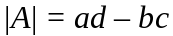 and A⁻¹ =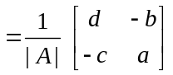

Transformations
Dilation 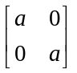 Shear 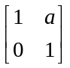 and 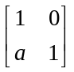

Rotation 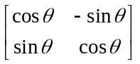 Reflection 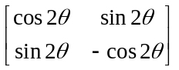

Mathematical reasoning
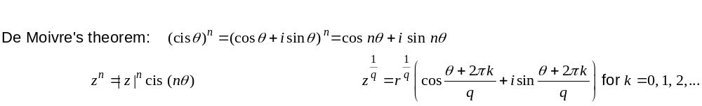
Measurement

Trapezium: Area = 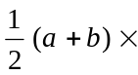height, where a and b are the lengths of the parallel sides

Prism: Volume = Area of base height

Cylinder: Total surface area = 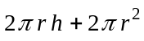
Volume = 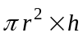

Pyramid: Volume = area of base height

Cone: Total surface area =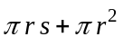, s is the slant height
Volume = 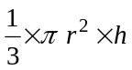

Sphere: Total surface area = 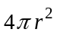
Volume = 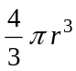
Note: Any additional formulas identified by the examination panel as necessary will be included in the body of the particular question.

